Downs syndrome Detection using Deep learning 

Department of CSE/IT

Jaypee Institute of Information Technology University, Noida

SUMMER PROJECT REPORT

Under the supervision of:

Mrs. Ambalika Sarkar

Submitted By:

Arjun Singh Chauhan 9918103063

ACKNOWLEDGEMENT

I would like to place on record my deep sense of gratitude to Ma’am Ambalika Sarkar, Assistant Professor, Jaypee Institute of Information Technology, India for her generous guidance, help and useful suggestions.

I also wish to extend my thanks to my fellow classmates for their insightful comments and constructive suggestions to improve the quality of this project work.

Signature(s) of Student



Archit Gupta 9918103062



Arjun Singh Chauhan 9918103063



Heena Nankani 9918103102



Kapil Sharma 9918103104

DECLARATION

We hereby declare that this submission is our own work and that, to the best of our knowledge and beliefs, it contains no material previously published or written by another person nor material which has been accepted for the award of any other degree or diploma from a university or other institute of higher learning, except where due acknowledgment has been made in the text.

Place: JIIT, Noida

Date: 4 May’ 21

Archit Gupta

9918103062

Arjun Singh Chauhan

9918103063

Heena Nankani

9918103102

Kapil Sharma

9918103104

CERTIFICATE

This is to certify that the work titled “Down Syndrome Detection Using Deep Learning” submitted by Archit Gupta, Arjun Singh Chauhan, Heena Nankani and Kapil Sharma of B.Tech of Jaypee Institute of Information Technology, Noida has been carried out under my supervision. This work has not been submitted partially or wholly to any other University or Institute for the award of any other degree or diploma.

ABSTRACT

Down syndrome (sometimes called Down's syndrome) is a condition in which a child is born with an extra copy of their 21st chromosome — hence its other name, trisomy 21. This causes physical and mental developmental delays and disabilities. Detection of this disease is an important task. Recent studies showed that facial recognition technologies have the capability to identify genetic disorders. However, there is a paucity of studies on the automatic identification of Down syndrome with facial recognition technologies, especially using deep convolutional neural networks. Here, we developed a Down syndrome identification method utilizing facial images and deep convolutional neural networks, which quantified the binary classification problem of distinguishing subjects with Down syndrome from healthy subjects based on unconstrained two-dimensional images. Clinicians can then further advise if a baby should further be biologically tested for Down syndrome based on the predictions from the model. The network was trained (721 images) and tested (202 images) on a dataset of 477 Down syndrome and 244 healthy images curated through public databases. In the final testing, the model achieved 94.50% accuracy in Down syndrome identification. Our findings indicate that the Transfer Learning has the potential to support the fast, accurate, and fully automatic identification of Down syndrome and could add considerable value to the future of precision medicine.

TABLE OF CONTENTS

1. Introduction 7 2. Background Study 8 3. Hardware and Software Requirement 10 4. Detailed Design 11 5. Implementation 13 6. Experiment and Analysis 15 7. Conclusion 16 8. References 17

.

INTRODUCTION

Down syndrome is one of the most common genetic syndromes caused by a chromosome 21 abnormality with a prevalence of 1:1000–1100 worldwide [1]. Patients with Down syndrome are typically associated with characteristic facial features, physical growth delays, mild to moderate intellectual disabilities [2–7], and an increased risk of complications for respiratory and hearing problems, as well as heart defects [5,8]. Early diagnosis is necessary to prevent the occurrence of potential health problems and to benefit patients with lifelong healthcare involving physical, speech, cardiac, and neurological therapies [9]. The diagnosis of Down syndrome can be conducted during pregnancy or after birth [10,11]. Screening for Down syndrome is recommended as universally offered to pregnant women and is a critical component of antenatal care [12–14]. After birth, Down syndrome can be identified by the presence of some typical facial characteristics [5–7,15,16]. Some of these features include upslanted palpebral fissures, a flat nasal bridge, widely spaced eyes, a protruding tongue, and small ears and nose.

Recent advances in computer vision and deep learning present the opportunity for development in many fields. The performance of tasks such as object detection, localization, recognition, and segmentation based on public datasets has dramatically improved in recent years .

BACKGROUND STUDY

One of the main types of deep learning methods, the deep convolutional neural network (DCNN), applies a series of layers, including convolution layers, pooling layers, and fully connected layers, with thousands or even millions of trainable parameters that are continuously updated with a backpropagation algorithm to minimize the loss between the outputs and targets during the training process. In medicine, deep learning has demonstrated significant advantages in disease diagnosis and lesion segmentation due to its powerful capacity for feature extraction . The distinctive facial characteristics of Down syndrome might also provide an opportunity for automatic identification. In recent years, few studies have been undertaken to identify cases of Down syndrome using two-dimensional or three

dimensional facial images. A study proposed by Zhao et al. [9] used facial geometric and texture biomarkers for Down syndrome identification with 2D facial images. The facial characteristics were presented with geometric features based on facial anatomical landmarks, local texture features based on contourlet transform, and local binary patterns. The normal and abnormal cases were discriminated by machine learning (ML) methods, including support vector machine (SVM) and k

Nearest Neighbors (KNN). However, this method needed to manually extract geometric features from patients, and the dataset only involved 24 Down syndrome cases and 24 normal cases. To our knowledge, there have not been any published reports related to the use of Transfer Learning for the prediction of down syndrome.

Following is the summary of our research done before we started with the project

https://docs.google.com/spreadsheets/d/1pBrgYA9D6wpc

S9s4A2vyxO8NumeJR56HLlZBZU0PbM/edit?usp=sharing

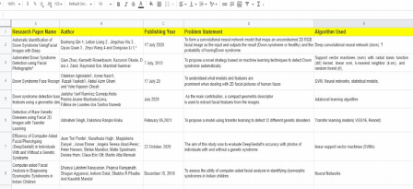

Convolutional Neural Network

In neural networks, Convolutional neural networks (ConvNets or CNNs) is one of the main categories to do image recognition, images classifications. Objects detections, recognition faces etc., are some of the areas where CNNs are widely used.

The above figure is how the training of the CNN actually works behind the keras API. The image is converted into an array of numbers denoting the intensity of each pixel. From here there comes multiple layers of pooling and convolutional. Stacking up of these different types of layers is what makes CNN a deep learning network.

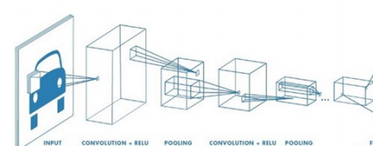

Data Limitation

CNN is a data hungry algorithm. This means to get any meaningful result they need a lot of data to actually give a satisfactory result.We usually don't have this much data at our disposal. For this we have to use transfer learning.

Transfer Learning

Transfer learning is a research problem in machine learning that focuses on storing knowledge gained while solving one problem and applying it to a different but related problem. For example, knowledge gained while learning to recognize cars could apply when trying to recognize trucks

In transfer learning we use a pretrained model. Then we retrain some of its weights according to our need.

For example in our case we are going to use a pre trained neural network for facial feature detection. Then we are going to add a few layers. Then we will train these layers with the limited dataset of downs syndrome face images.

This might seem magical but there is a simple logic. The model learns the basic features like the location of eyes, nose, lips etc from the pre trained network on the other hand down's syndrome patients have distinct facial features and orientation. These can be detected using the new layers we add at the end of the model.

After our model is trained the user can input any face image to the model and it can detect whether the person is having downs syndrome or not.

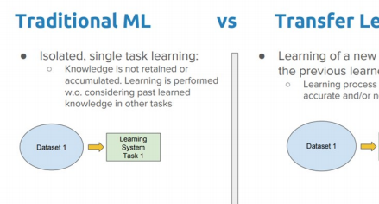

ResNet50 architecture

ResNet50 is a variant of the ResNet model which has 48 Convolution layers along with 1 MaxPool and 1 Average Pool layer. It has 3.8 x 10^9 Floating points operations. It is a widely used ResNet model and we have explored ResNet50 architecture in depth.

• A convolution with a kernel size of 7 \* 7 and 64 different kernels all with a stride of size 2 giving us 1 layer.

• Next we see max pooling with also a stride size of 2.

• In the next convolution there is a 1 \* 1,64 kernel following this a 3 \* 3,64 kernel and at last a 1 \* 1,256 kernels, These three layers are repeated in total 3 times so giving us 9 layers in this step.

• Next we see kernel of 1 \* 1,128 after that a kernel of 3 \* 3,128 and at last a kernel of 1 \* 1,512 this step was repeated 4 times so giving us 12 layers in this step.

• After that there is a kernel of 1 \* 1,256 and two more kernels with 3 \* 3,256 and 1 \* 1,1024 and this is repeated 6 times giving us a total of 18 layers. • And then again a 1 \* 1,512 kernel with two more of 3 \* 3,512 and 1 \* 1,2048 and this was repeated 3 times giving us a total of 9 layers.

• After that we do a average pool and end it with a fully connected layer containing 1000 nodes and at the end a softmax function so this gives us 1 layer.

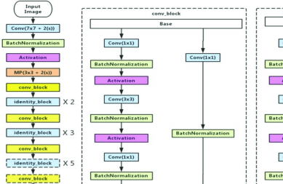Flask

Flask is a micro web framework written in Python. It is classified as a microframework because it does not require particular tools or libraries.It has no database abstraction layer, form validation, or any other components where pre existing third-party libraries provide common functions. However, Flask supports extensions that can add application features as if they were implemented in Flask itself. Extensions exist for object-relational mappers, form validation, upload handling, various open authentication technologies and several common framework related tools.

Flask allows us to create interactive web applications at a lightning fast pace since it has very little boilerplate content for getting started.

Features of flask include:

• Development server and debugger

• Integrated support for unit testing

• RESTful request dispatching

• Uses Jinja templating

• Support for secure cookies (client side sessions)

• 100% WSGI 1.0 compliant

• Unicode-based

• Extensive documentation

• Google App Engine compatibility

• Extensions available to enhance features desired

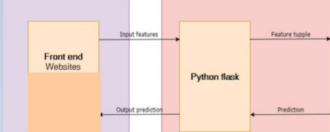

HARDWARE AND SOFTWARE REQUIREMENTS

Since during the training of the model we are going to use Convolutional Neural Network we would be needing good hardware.

For training we would be using system with :

● 8GB RAM

● MX150 Graphic Card

● Faster NVMe storage

● I7 8th generation processor

Apart from this we would be using google colab hardware which provides Kirin graphic card depending upon availability.

For our software component we would be using:

● Keras for creating models

● Tensorflow

● Python

● Convolutional Neural Network

● Transfer Learning

At the later end of our project we are also motivated to deploy our model if the time permits. In that case we are going to deploy our model using the apache web server.

DETAILED DESIGN

The workflow of our project is divided into several steps. Firstly we created a complete dataset for the downs syndrome facial detection. This is a tedious task since the dataset is not readily available.

After this we have to train our model.

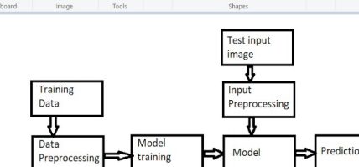

• Any machine learning lifecycle has critical dependency on the dataset. So the first step is the most crucial. We have to collect the accurate dataset. • Once we get hold of the dataset we have to segregate it in folders. This is important for a smooth functioning of the training pipeline

• When we train the model there is always the risk of over training or under training. I.e overfitting or underfitting. So we have to keep evaluating the model and tune the hyperparameters

• The preprocessing of images before training is very important in any deep learning model. All the deep learning models are heavily dependent on data. The data is usually very limited. So we have to preprocess the data which involves data augmentation .

• Data augmentation helps increase the size of the dataset. This is helpful in increasing the accuracy of the model.

• Once the model is trained according to our need we can make predictions. Model training often takes a lot of time so we usually save the model and to make predictions on it at a later stage

• This model functions as the backend to the flask API.

IMPLEMENTATION

The working of our end to end implementation is based on flask. The complete workflow is given in below points:

1. The flask application is deployed and hence the user can use the URL to connect to the frontend of the application.

2. The user is then prompted to upload the image of his choice to be classified as either being down's syndrome positive or downs syndrome negative. 3. When the user submits the detail the flask calls the python script which is responsible for making the prediction.

4. Depending upon the classification that is made by the model the script calls the output page and the user is shown the results on the webpage.

The model we are using is based on transfer learning on Resnet50 architecture. The model is already trained and hence when the user uploads the image the script only runs the predict function and doesnt train it since it is already trained.

ML MODEL

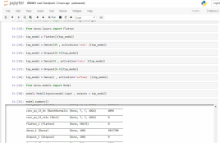

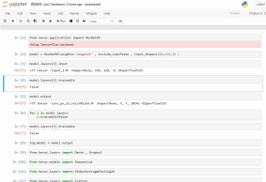

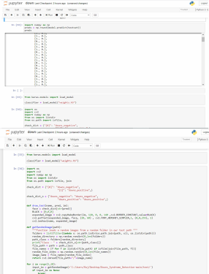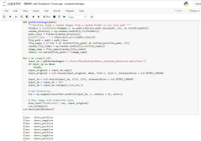

FRONTEND





EXPERIMENTAL RESULTS AND ANALYSIS

As stated we received maximum accuracy when we used the Resnet50 architecture which accounts to be so and so. We then worked on the flask part for deployment purposes. A simple webpage accepts an image as input which can further be used as input for the prediction function. The function uses saved weights from our trained and saved model and gives results in the form of 0(negative) or 1(positive). The results are then displayed on a new web page.

Down Syndrome Identification Results The accuracy was an important factor for measuring the performance of the network.

Accuracy = (TP + TN) / (TP + TN + FP + FN)

where TP, TN, FP, and FN correspond to true positive, true negative, false positive, and false negative, respectively.

The accuracies of various models we have created is given below

For various models we are getting good accuracy results:

VGG19: 86,87%

VGG16: 84.74%

MobileNet: 90.39 %

ResNet: 94.50%

For our final model we chose the Resnet architecture.







CONCLUSION AND FUTURE SCOPE

Our project aimed at creating a deep learning model to detect the presence of down syndrome by seeing their image. To make this project accessible for non technical users we created a web application so that anyone can use our application.

In this project, we proposed an automatic identification of Down syndrome using digital facial images with Transfer Learning. The proposed model contains three steps: image preprocessing, general facial recognition using pre trained networks, and Down syndrome identification using fine tuning last layers of the model for the down syndrome dataset. The performances of the proposed method were measured in terms of its accuracy. The experimental results show that Down syndrome was detected with 94.50% accuracy. The results indicate that our method has great potential to support the automatic identification of Down syndrome from facial image data and would be useful for the early screening and prevention of disease progression.

In future studies, we can investigate various genetic diseases that affect facial features and will apply genome sequencing data to assist in clinical diagnosis and to open a new pathway in the field of precision medicine.

REFERENCES

1. Vorravanpreecha, N.; Lertboonnum, T.; Rodjanadit, R.; Sriplienchan, P.; Rojnueangnit, K. Studying Down syndrome recognition probabilities in Thai children with de-identified computer-aided facial analysis. Am. J. Med. Genet. A 2018, 176, 1935–1940. [CrossRef] [PubMed]

2. Weijerman, M.E.; de Winter, J.P. Clinical practice. The care of children with Down syndrome. Eur. J. Pediatr. 2010, 169, 1445–1452. [CrossRef] [PubMed]

3. Kruszka, P.; Porras, A.R.; Sobering, A.K.; Ikolo, F.A.; La Qua, S.; Shotelersuk, V.; Chung, B.H.; Mok, G.T.; Uwineza, A.; Mutesa, L.; et al. Down syndrome in diverse populations. Am. J. Med. Genet. A 2017, 173, 42–53. [CrossRef] [PubMed]

4. Cohen, M.M.; Winer, R.A. Dental and Facial Characteristics in Down’s Syndrome (Mongolism). J. Dent. Res. 1965, 44, 197–208. [CrossRef] [PubMed]

5. Fink, G.B.; Madaus, W.K.; Walker, G.F. A quantitative study of the face in Down’s syndrome. Am. J. Orthod 1975, 67, 540–553. [CrossRef]

6. Strelling, M.K. Diagnosis of Down’s syndrome at birth. Br. Med. J. 1976, 2, 1386. [CrossRef] [PubMed]

7. Fisher, W.L., Jr. Quantitative and qualitative characteristics of the face in Down’s syndrome. J. Mich Dent. Assoc. 1983, 65, 105–107.

8. Roizen, N.J.; Patterson, D. Down’s syndrome. Lancet 2003, 361, 1281–1289. [CrossRef]

9. Zhao, Q.; Rosenbaum, K.; Sze, R.; Zand, D.; Summar, M.; Linguraru, M.G. Down Syndrome Detection from Facial Photographs using Machine Learning Techniques. In Medical Imaging 2013: Computer-Aided Diagnosis; Novak, C.L., Aylward, S., Eds.; Spie-Int Soc Optical Engineering: Washington, WA, USA, 2013; Volume 8670.

10. Collins, V.R.; Muggli, E.E.; Riley, M.; Palma, S.; Halliday, J.L. Is Down syndrome a disappearing birth defect? J. Pediatr. 2008, 152, 20–24. [CrossRef]

11. Schepis, C.; Barone, C.; Siragusa, M.; Pettinato, R.; Romano, C. An updated survey on skin conditions in Down syndrome. Dermatology 2002, 205, 234–238. [CrossRef]

12. Malone, F.D.; Canick, J.A.; Ball, R.H.; Nyberg, D.A.; Comstock, C.H.; Bukowski, R.; Berkowitz, R.L.; Gross, S.J.; Dugoff, L.; Craigo, S.D.; et al. First-trimester or second-trimester screening, or both, for Down’s syndrome. N. Engl. J. Med. 2005, 353, 2001–2011. [CrossRef]

13. Snijders, R.J.M.; Noble, P.; Sebire, N.; Souka, A.; Nicolaides, K.H.; Grp, F.M.F.F.T.S. UK multicentre project on assessment of risk of trisomy 21 by maternal age and fetal nuchal-translucency thickness at 10–14 weeks of gestation. Lancet 1998, 352, 343–346. [CrossRef]

14. Chiu, R.W.; Akolekar, R.; Zheng, Y.W.; Leung, T.Y.; Sun, H.; Chan, K.C.; Lun, F.M.; Go, A.T.; Lau, E.T.; To, W.W.; et al. Non-invasive prenatal assessment of trisomy 21 by multiplexed maternal plasma DNA sequencing: Large scale validity study. BMJ 2011, 342, c7401. [CrossRef] [PubMed]

15. Damasceno, L.N.; Basting, R.T. Facial analysis in Down’s syndrome patients. RGO–Revista Gaúcha de Odontol. 2014, 62, 7–12. [CrossRef]

16. Dimitriou, D.; Leonard, H.C.; Karmiloff-Smith, A.; Johnson, M.H.; Thomas, M.S. Atypical development of configural face recognition in children with autism, Down syndrome and Williams syndrome. J. Intellect. Disabil. Res. 2015, 59, 422–438. [CrossRef] [PubMed]

17. Saraydemir, S.; Taspinar, N.; Erogul, O.; Kayserili, H.; Dinckan, N. Down syndrome diagnosis based on Gabor Wavelet Transform. J. Med. Syst. 2012, 36, 3205–3213. [CrossRef]